AI LITERACY COURSE
Arrival: Honest A&E Wait Times
Student tutorial · Work through this in your group, one step at a time
BEFORE YOU START
You need one laptop per group that can install software, a working internet connection, and about 15 minutes. Only one person needs to do the install. Everyone else should watch the screen. You will not be asked for an administrator password and nothing is installed system-wide: everything this app needs goes inside its own folder, and deleting that folder removes every trace of it.

Hong Kong's Hospital Authority publishes one number per emergency department: roughly how long someone arriving right now will wait. One number, with no sense of whether it is high or low for a Tuesday afternoon. Arrival takes that same public number and adds the only thing that makes it mean anything, which is what that department usually publishes at this hour.
This tutorial gets it running on your laptop and then walks you through what it is telling you. The interesting part is not the forecast. It is the places where the app refuses to give you one.

Step 1 · Get the project onto your laptop
The whole project lives in one public GitHub repository. GitHub is where code is shared and where you can read every line of it before you run it. That is worth doing here, because you are about to run a program on your own machine.
Go to https://github.com/northlight7/arrival-ae-wait-times
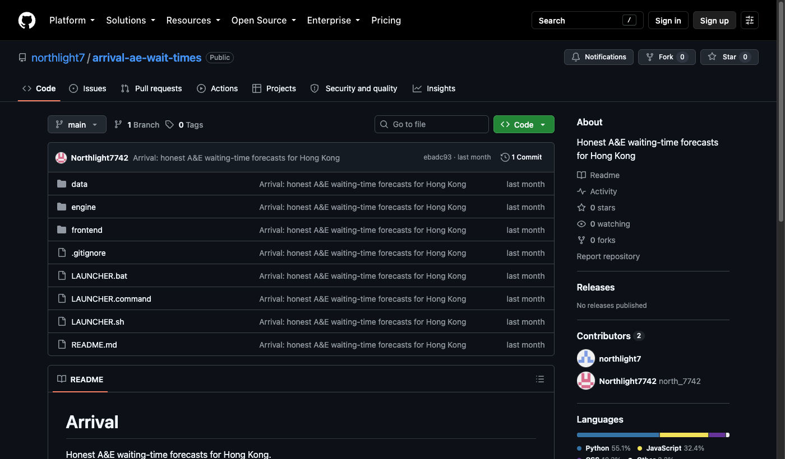
The project on GitHub. Three folders and three launchers is the whole thing. The right-hand column shows who wrote it and when it last changed.

1.1 Download it
1. Click the green Code button near the top right.
2. In the menu that drops down, click Download ZIP at the bottom.
3. The download is about 8 MB. Most of that is the stored history of A&E waiting times, which is the part that makes the app worth anything.
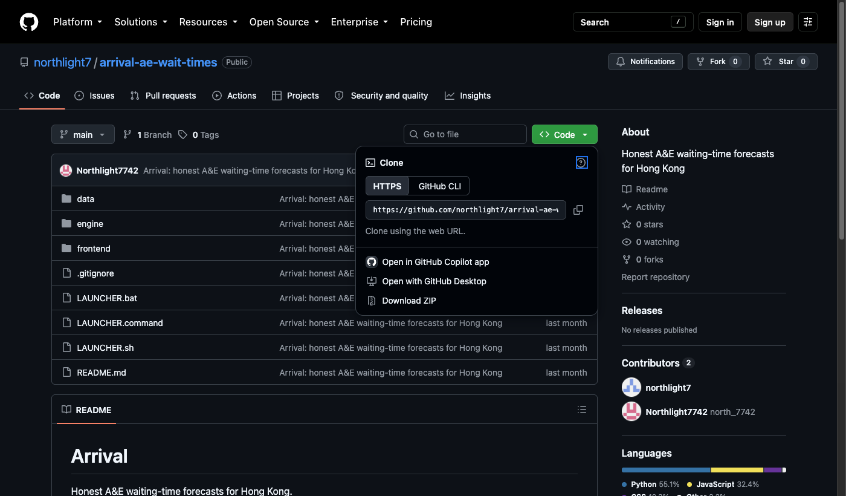
Code, then Download ZIP. Ignore the Clone options above it: those are for people who already use git.

1.2 Extract it properly
This is the step groups get wrong, so read it carefully. A .zip file is a box. On both Windows and macOS you can look inside the box without opening it, and if you run the launcher from in there it will fail, because the rest of the project is still in the box.
On Windows
1. Find the downloaded file in your Downloads folder.
2. Right-click it and choose Extract All.
3. Accept the folder it suggests and click Extract. A new folder called arrival-ae-wait-times-main appears. That folder, not the .zip, is the project.
On a Mac
1. Double-click the downloaded .zip in your Downloads folder. macOS extracts it beside the .zip and you are done.
MOVE IT SOMEWHERE SENSIBLE
Drag the extracted folder out of Downloads and onto your Desktop, or into Documents. Downloads folders get cleared automatically on some machines, and the app stores everything it installs inside this folder.

Step 2 · Start it
There is no installer and no setup wizard. You double-click one file and it does the rest: it downloads its own private copy of Python, installs the one library it needs, and starts a small web server on your own machine. Nothing is sent anywhere and nothing touches the rest of your computer.
Open the extracted folder and find the launcher for your machine.
Your computer | Double-click this file
Windows | LAUNCHER.bat
Mac | LAUNCHER.command

A black window opens and starts talking to you. This window is the app. Do not close it: closing it stops Arrival.

2.1 What you should see
The first run takes a minute or two, because it is downloading Python. Every run after that starts in a couple of seconds.
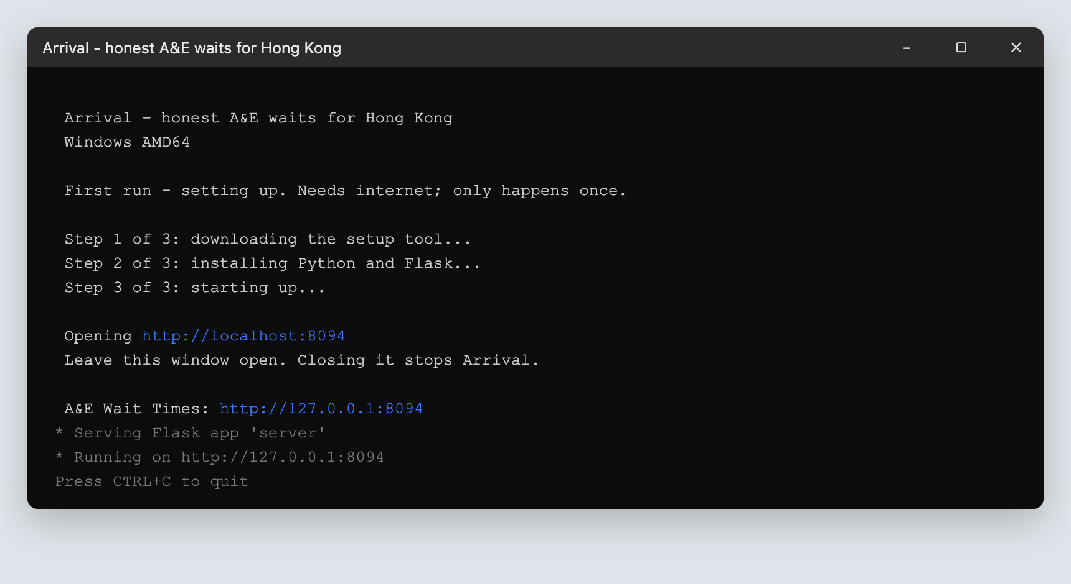
Windows. Three numbered steps, then a link. The window must stay open.
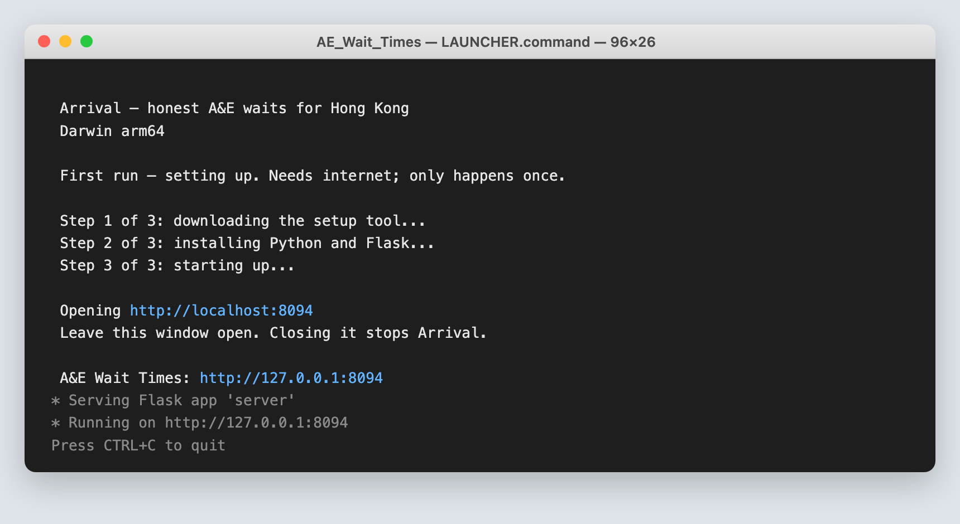
macOS. The same three steps in the Terminal.
When it reaches Step 3 your browser opens on its own. If it does not, open a browser yourself and type this in:
http://localhost:8094

2.2 The two warnings you may hit
Windows: “Windows protected your PC”
A blue box may appear when you run LAUNCHER.bat. This is SmartScreen, and it appears because the file is new to Microsoft, not because anything is wrong with it. Click More info, then Run anyway.
Mac: “LAUNCHER.command cannot be opened”
If macOS refuses to open it, right-click the file (or Control-click it) and choose Open from the menu instead of double-clicking. You will be asked once more, and after that it opens normally.
STOP AND THINK
You have just told your computer to ignore a security warning twice. That was the right call here, for one specific reason: you can read every line of this program's source code on GitHub, and you know who wrote it. It would be the wrong call for a file a stranger emailed you. Write down, in one sentence, what made the difference.

2.3 If it will not start
What the window says | What to do
The 'engine' folder is missing | You ran the launcher from inside the .zip. Go back to Step 1.2 and extract it properly.
Could not download the setup tool | Your network is blocking the download. A file called setup-log.txt now sits next to the launcher, and it says why. School and office Wi-Fi often blocks this; a phone hotspot usually works.
The historical data file is missing | The extraction did not finish. Delete the folder and extract the .zip again.
The window flashes and vanishes | On Windows, open the folder, type cmd in the address bar, press Enter, then type LAUNCHER.bat and press Enter. Now the error stays on screen.

CHECKPOINT
Before moving on, everyone in your group should be able to see the Arrival page open in a browser on the group laptop, with a blue banner reading “Which emergency room should you actually go to?”

Step 3 · Read what it is telling you
The page answers one question, and everything on it is arranged around that question rather than around the data. Work down it in order.
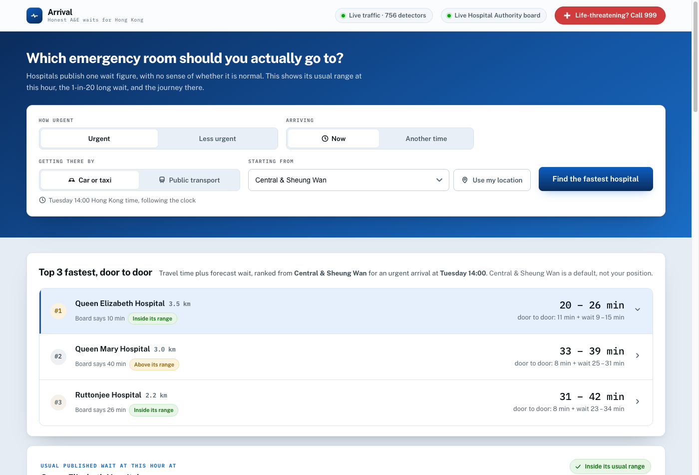
The page as it opens. Controls at the top, the answer underneath.

3.1 The controls
Control | What it means
How urgent | Which triage band. Urgent is category III, the largest group of walk-in patients. Less urgent covers categories IV and V.
Arriving | Now, or a day and hour you choose. This matters more than it looks. Step 4 is entirely about it.
Getting there by | Car or taxi uses live road speeds. Public transport is modelled from distance.
Starting from | A district, or Use my location. With no starting point the app ranks by queue alone and tells you so.

3.2 The top three
The first card answers the actual question. Not “which hospital has the shortest queue” but “which hospital gets me seen soonest”, which is travel time plus queue. These are usually different hospitals.
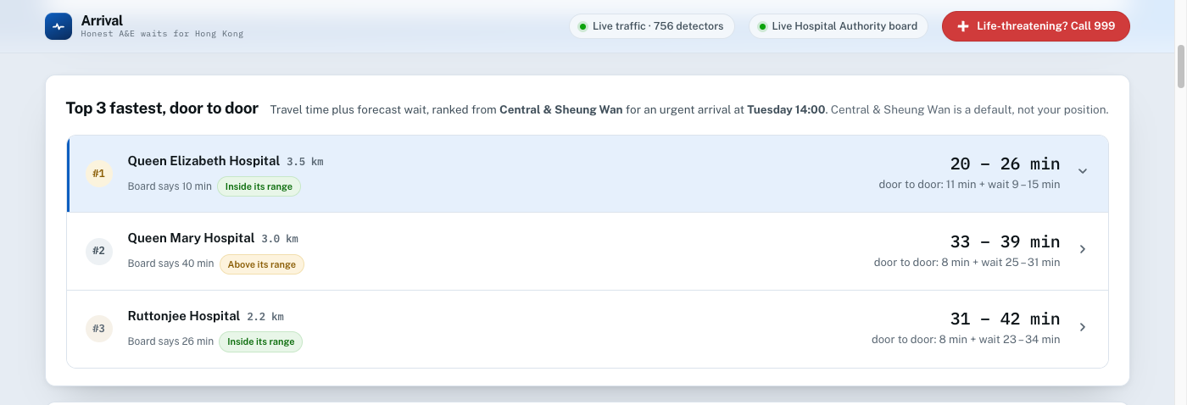
Ranked by door-to-door time. Queen Mary has a shorter drive than Queen Elizabeth, but a queue long enough to lose the race.
Each row carries a coloured tag: Inside its range, or Above its range. That tag is the whole point of the project. It does not say the department is slow. It says the department is slower than it usually is at this hour.

3.3 The answer card
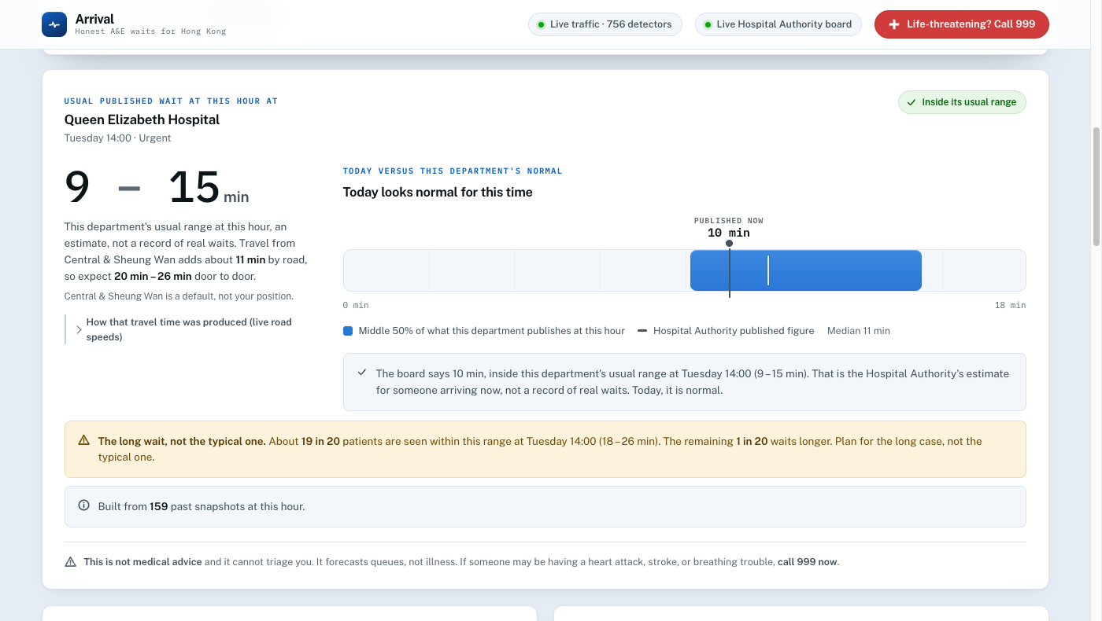
One department in detail. The blue bar is its own history at this hour. The black line is what the board says right now.
What you see | What it is
The big interval | The middle half of everything this department has published at this hour of this weekday. Never a single number, because a single number would imply a precision the data does not have.
The blue bar | That same interval, drawn to scale, with the median marked inside it.
The black line | Today's published figure, dropped onto that history. Inside the blue bar means today is normal.
The amber box | The 1-in-20 long wait. Nineteen people in twenty are seen within it. The twentieth waits longer. Plan around this, not the median.
Built from N snapshots | How much evidence is behind the estimate. A small number here means treat the answer with suspicion, and the app says so on screen.

3.4 The charts and the table
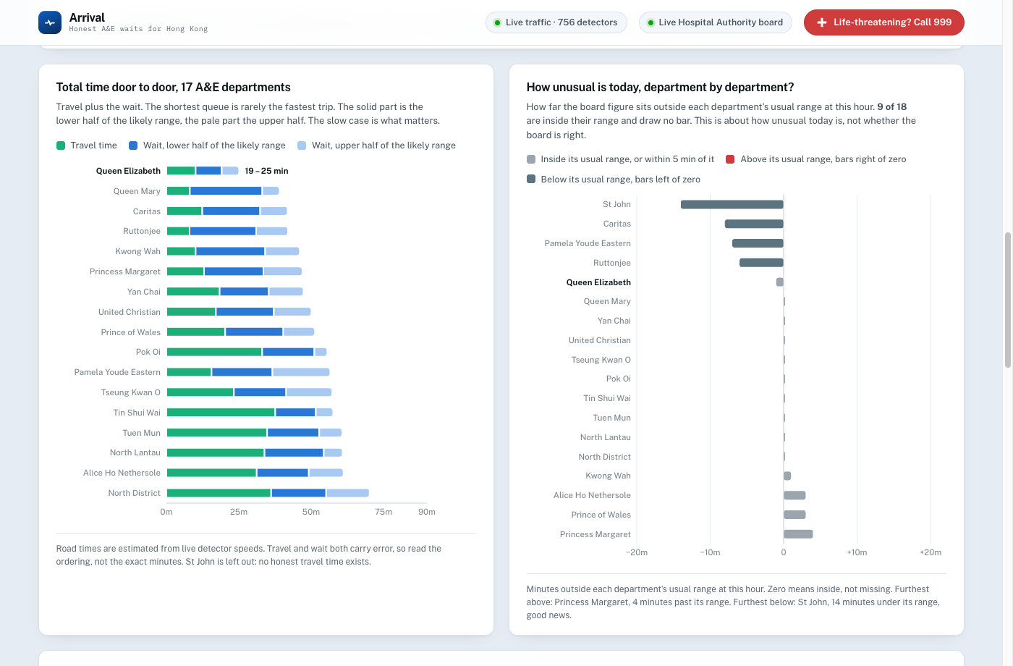
Left: door-to-door time for every department, green for travel and blue for queue. Right: how far each department sits outside its own usual range today.
Read the left chart as an ordering, not as exact minutes. Both halves of each bar carry error. The right chart is the more honest one: a department with no bar is having a completely ordinary day, and most days most departments have no bar.
NOTICE WHAT IS MISSING
The left chart says 17 departments. The count below the page says 18. The caption explains the gap: St John Hospital is on Cheung Chau and can only be reached by ferry, so no honest road travel time exists for it and it is left out rather than given a made-up one. Look for that sentence on your screen.

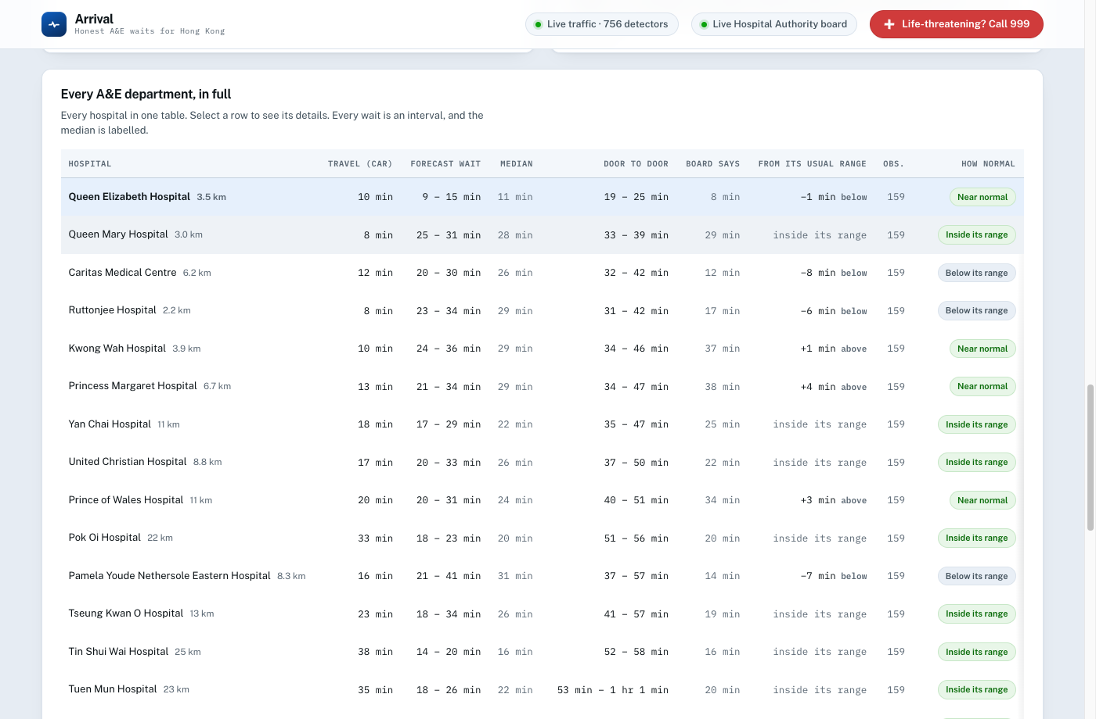
Every department in one table. Select a row to make it the subject of the answer card above.

Step 4 · Make it refuse to answer
This is the part to spend time on. Most software, asked a question it cannot answer, answers anyway. This one does not, and you can trigger that on purpose.
1. At the top of the page, click Another time.
2. Two new dropdowns appear: Day and Hour of arrival.
3. Set them to a day and hour that is not right now. Saturday, 03:00 works well.
4. Click Find the fastest hospital.
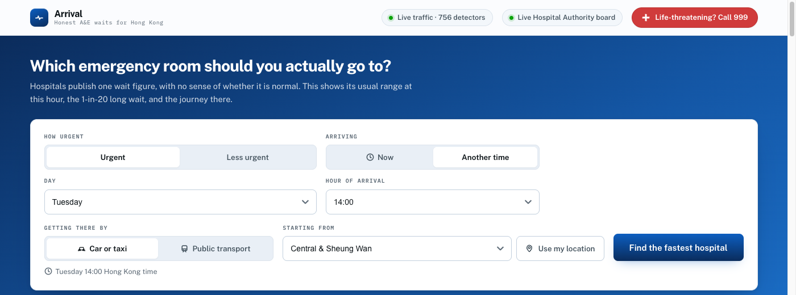
Another time reveals the day and hour controls.
Now look at what changed.
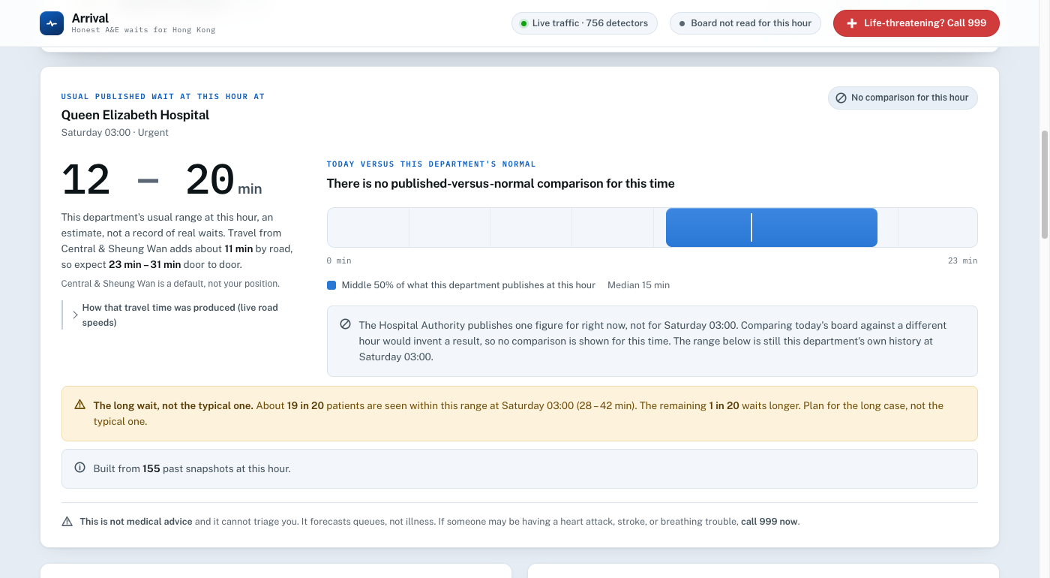
The forecast is still there. The comparison is gone, and a sentence explains why instead of leaving a blank.
The forecast range, the 1-in-20 long wait and the travel time are all still shown, because those come from stored history and history exists for every hour of the week. What vanished is the comparison against today's board, and the reason is stated in full: the Hospital Authority publishes one figure, for right now. There is no published figure for Saturday 03:00, and there never will be. Subtracting today's number from Saturday's history would produce a result, and the result would be meaningless.
Look at the top right of the page as well. The green pill that read “Live Hospital Authority board” has gone grey and now reads “Board not read for this hour”. The whole page agrees with itself.
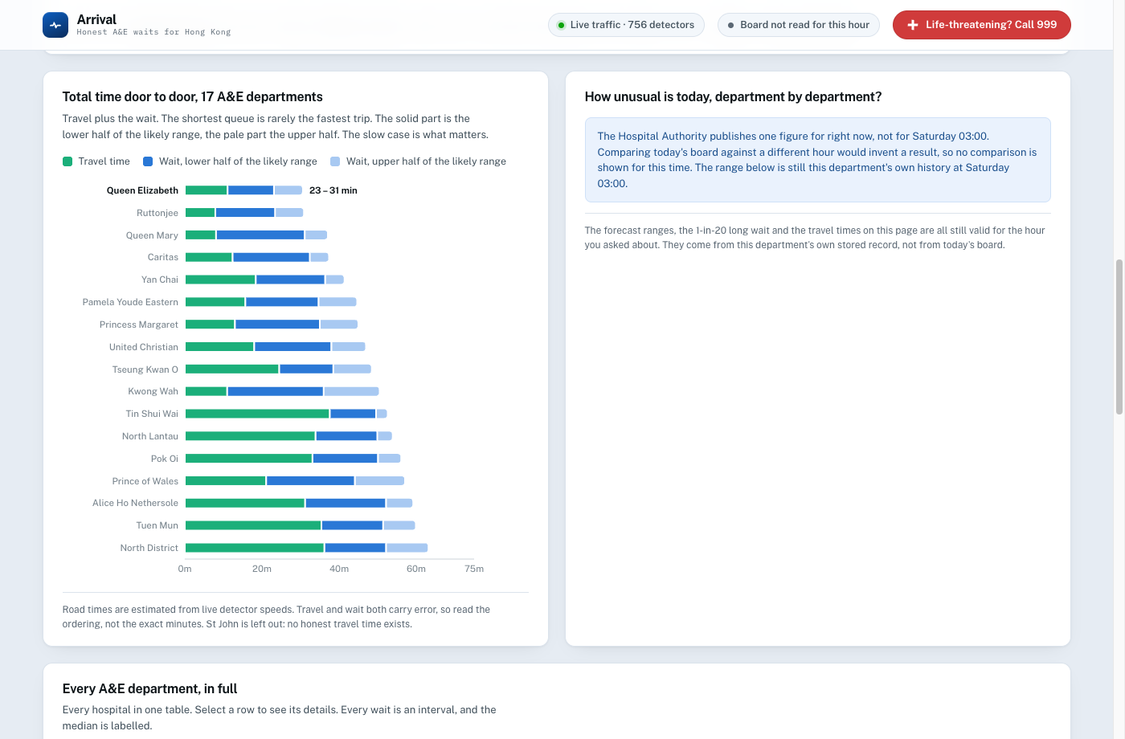
The department-by-department chart does not draw at all. It explains itself in the space where the chart would have been.
STOP AND THINK
An earlier version of this app did compare today's board against whichever hour you asked for. On one Tuesday reading, a single hospital produced four different answers for four different hours, all from the same one figure, and the page presented each as an observation. Nothing was broken and no error appeared. Discuss in your group: how would a user ever have known?

TRY THIS TOO
Set Starting from to “Anywhere (no travel time)” and re-run it. The ranking changes, and the page tells you it is now ranking by queue alone and that the nearest hospital may still be the faster choice. It does not quietly invent a location for you.

Step 5 · Check its working
At the bottom of the page is a section called What this is built on. Open the grey fold inside it marked How the numbers work.
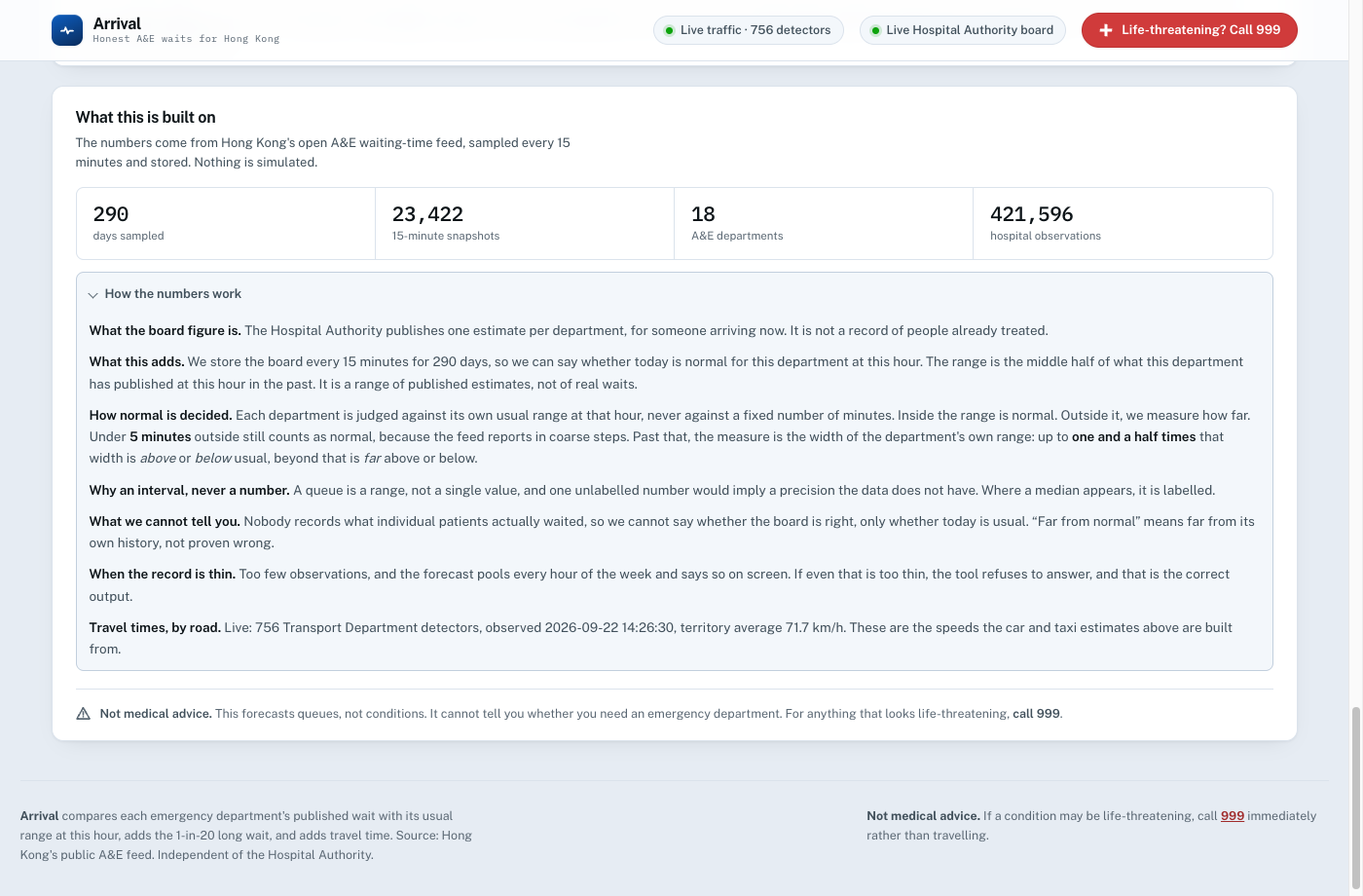
The methodology, written for the reader rather than filed in a separate document nobody opens.
Read the paragraph headed “What we cannot tell you”. It says, in the app itself, that nobody records what individual patients actually waited, so this tool cannot tell you whether the board is right. Only whether today is usual.
THE QUESTION TO TAKE AWAY
That limitation was always true of this data. It was true of the official figures before this app existed. The difference is that Arrival says it, on screen, next to the number it affects. In your group, name one AI tool you have used that tells you what it cannot do. If you cannot name one, that is the finding.

Where the numbers come from
Figure | Source
A&E waiting times | Hospital Authority public feed, sampled every 15 minutes
Road speeds | Transport Department detectors, around 750 of them, live
Everything else | Computed from those two. Nothing is simulated.

Both feeds are open data that anyone in Hong Kong can download. No account, no key, no permission. You could check every number on the page yourself, and the point of the project is that you should be able to.

When you are finished
Close the black window. That stops the app. To delete it completely, drag the whole folder to the Bin: the private copy of Python lives inside it, so nothing is left behind on your computer.
NOT MEDICAL ADVICE
Arrival forecasts queues, not conditions. It cannot tell anyone whether they need an emergency department. In a real emergency in Hong Kong, call 999.

